Homework: Monday, March 27, 2017
Solve the following problems. You MUST show your work. NO WORK = NO CREDIT
Tre drew a scale drawing of the elementary school. The scale of the drawing was 1 centimeter = 6 meters. The school yard is 66 meters wide in real life. How wide is the school yard in the drawing? | Janet wants to make a triangular garden. She wants to use her house as one side of the triangle and use two pieces of fence to close the triangle. If her house is 10 feet long, and the two pieces of fence that she bought are 8 feet and 6 feet long, will she be able to the garden fence?
What is the shape of the resulting cross-section when a cylinder is  - sliced perpendicular to its base:  - b) sliced parallel to its base: | A bicycle tire has a diameter of 15.5 inches. How many times will the tire rotate if the bike travels 20 feet?
An angle and its supplement have a ratio of 5:1. What are the two angles? | A truck has a cargo bed that is 8ft by 5ft by 2ft. How many boxes can fit in the cargo bed if the boxes are 1ft long by 2ft wide by 2ft tall?
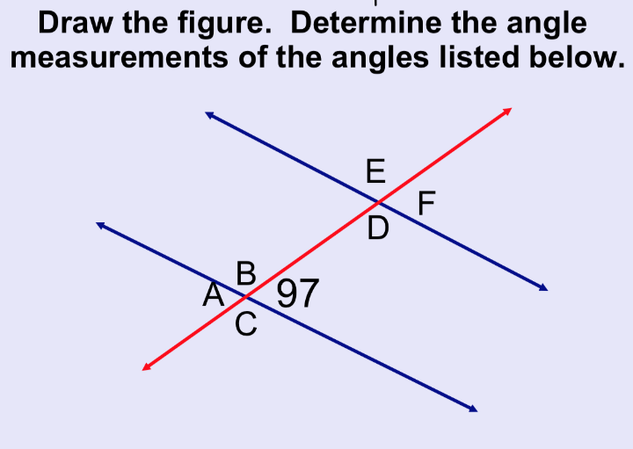 | Tori is floating on an inner tube that has a diameter of 4 feet. What is the inner tube's radius?
Homework: Tuesday, March 28, 2017
Solve the following problems. You MUST show your work. NO WORK = NO CREDIT
A scale drawing of a rectangular park is shown below.  The ratio of the scale drawing to the actual park is 2 inches (in.) to 25 yards (yd). What are the dimensions of the park? | Two sides of a triangle measure 3 inches and 9 inches. Write an inequality that represents all the possible lengths of the third side of the triangle, x?
A right rectangular prism with a square base is cut parallel to its base. The shape exposed is a cross section. Which shape best describes this cross section? | 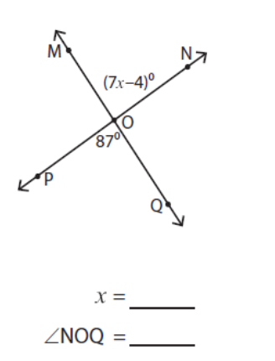  Find the value of x and the missing angle in the figure below.
Find the area and the circumference of the circle. Use π = 3.14. Calculate both πand exact forms.  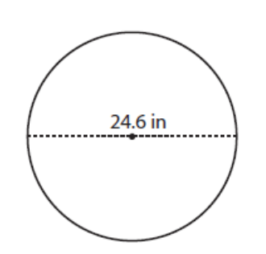 | Find the area of the composite shape below  .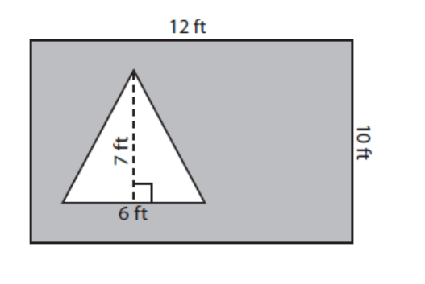
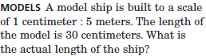 | 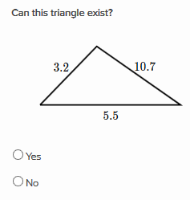

Homework: Wednesday, March 29, 2017
Solve the following problems. You MUST show your work. NO WORK = NO CREDIT
- (G.1)  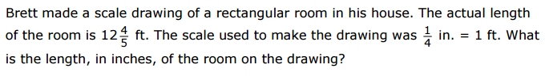 | - (G.2)  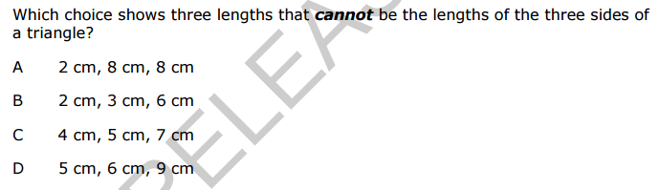
- (G.3)  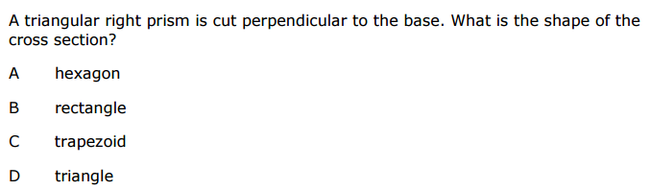 | - (G.4)  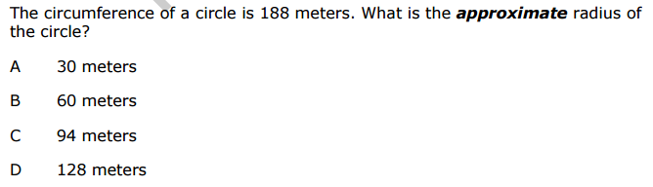
- (G.5)  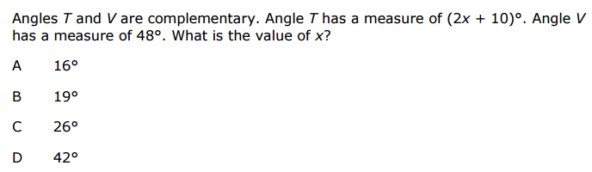 | 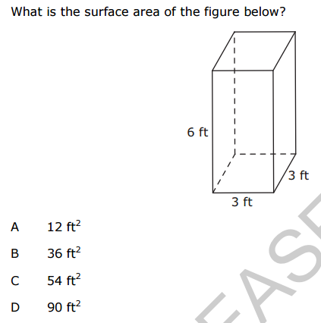  - (G.6)

