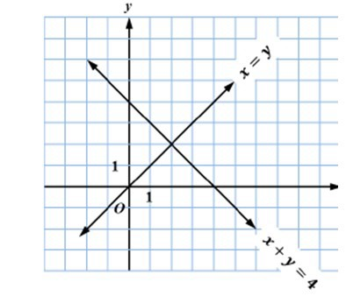
- (EE.8) Which point is the solution to both equations in the following graph?

  - (0, 0)
  - (0, 4)
  - (1, 1)
  - (2, 2)

- (EE.8) Line m goes through the points (1, 2) and (2, 1). Line n goes through the points (5, 2) and (4, 0). What is the point of intersection for line m and line n?

  - (2, -1)
  - (3, -2)
  - (11, 14)
  - (14, 11)

- (EE.8) What is the value of x in the solution to the system of equations below?

y = -x + 6
2x – y = -9

  - -1
  - 7
  - 9
  - 11

- (EE.8) The solution to a system of two linear equations is (­3,1). Determine which of the following equations could be the graphs of the two linear equations in the system.
  - y = -2x – 5
y = 2x – 5

  - y = 2x + 7
y = -⅔x – 1

  - y = -3x + 1
y = 3x – 1

  - y = ­2x + 7
y = 2x – 5

- (EE.8) Pamela’s age is 4 more than twice Shawn’s age. The sum of their age is 16. How old is Pamela?
  - 4 years old
  - 12 years old
  - 14 years old
  - 20 years old

- (F.4) A veterinarian plans to put a dog on a diet plan for ten weeks so the dog’s weight decreases by the same number of pounds per week. The table below shows how much the dog should weigh at different times on the diet plan.
Time on Diet Plan (Weeks) | Dog’s Weight (pounds)
3 | 93
6 | 87
9 | 81
12 | 75

Based on the data in the table, what is the dog’s initial weight in pounds?

  - 99 pounds
  - 97 pounds
  - 95 pounds
  - 93 pounds

- (F.5) In 2007, the population of a town was approximately 35,250. In 2012, the population of the town had decreased to 28,200. Based on a linear model, what would be the approximate population of the town in 2016?

  - 31,020
  - 26,800
  - 25,380
  - 22,560

- (F.4) An electrician charges a flat fee for a service call, plus a per hour charge to do the work. The total bill for a job that took 6 hours was $450. The total bill for a job that took 4 hours was $330. How much does the electrician charge per hour?

  - $60
  - $75
  - $85
  - $90

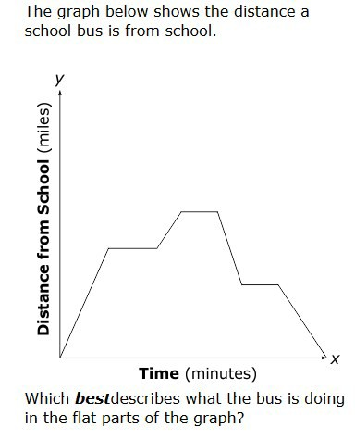
- (F.5)

  - Speeding up
  - Slowing down
  - Sitting still
  - Returning to school

- (EE.8) What is the value of y in the solution to the following systems of equation?
x + 2y = 1
2x – y = 7
- -1
- 2
- 3
- 4

- (EE.6) Points (2, 7) and (5, 13) are on one line, while points (-2, 0) and (0, -2) are on another line. The lines are…

  - The same
  - Parallel
  - Not parallel
  - Not enough information

- (F.4) The set of data in the table below represents a linear function.
x | y
-3 | -7$\frac{1}{2}$
-2 | -5$\frac{1}{2}$
-1 | -3$\frac{1}{2}$
Which is an equation for this function?
  - y = x – 1$\frac{1}{2}$
  - y = x – 2
  - y = 2x – 1$\frac{1}{2}$
  - y = 2x – 2

- (F.4) Art classes at Studio A cost $15 per class, plus a one-time fee of $20. The following functions represent the total cost, y, of taking x art classes at four other studios. Which function represents a studio with a cost per class less than Studio A?
  - y = 12x + 25
  - y = 15x + 11
  - y = 16x +14
  - y = 18x + 12

- (F.3) Which equation does not represent a linear function?

  - y = 2( x − 3)
  - y = 22 − 3x
  - y = $\frac{x+1}{2}$
  - y = 2x 2 + 3x

- (EE.7) The equation −2y + 8 = 3y − 7x is equivalent to…

  - y = $\frac{7x}{5}$ + 8
  - y = $7x+5$
  - y = $\frac{7x}{5}$ + $\frac{8}{5}$
  - y = 7x + 8

- (F.2) Fill in the table with the following values: {( 1, 3), (0, 4), (-1, 5)}. Which algebraic equation gives the correct rule for the table?
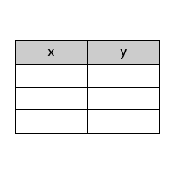
- y = 4x
- y = 3x
- y = - x + 4
- y = - x + 3

- (F.3) The equation x − 2y = 2x − 1 is…
  - Linear
  - Nonlinear
  - Not a function
  - Both A and C

- (F.3) Which of the following statements is not true for the equation 4x-2y =10
- The y-intercept is at -5
- Slope-intercept form of the line is y = 2x - 5
- It passes through the point (1,2)
- The line contains a positive slope

- (EE.7) The lines 3x + y − 1 = 2 and 2x − 2 = − y − x + 1 have…

- No Solutions
- 2 solutions
- Infinite solutions
- 1 solutions

- (EE.5) A garden hose is used to fill a swimming pool. In 150 minutes 19500 gallons of water is added to the pool. If this information was graphed the slope of the graph would be...

  - $\frac{15}{195}$
  - 130
  - $\frac{1}{130}$
  - $\frac{39}{3}$

- (EE.6) What is the slope of a line that passes through the points (5,3) and (1,2)?

- -4
- 4
- ¼
- -¼

- (EE.8) The length of a rectangle is 7 cm longer than the width. The perimeter of the rectangle is 46 cm. What is the width of the rectangle?

  - 8 cm
  - 15 cm
  - 17.5 cm
  - 20 cm

- (F.4) The set of data in the table below represents a linear function.
x | Y
-4 | 1
-2 | 2
0 | 3
Which is an equation for this function?
  - y = 4x + 3
  - y = 2x + 3
  - y = 0.5x + 3
  - y = 0.25x + 3

Key Strokes to remember:
Systems of Equations
{Y=} (enter the equations)
Example: y = 3x – 4 [{3} {X,T,O,N} {-} {4}]
y = -3x – 4 [{(-)} {3} {X,T,O,N} {-} {4}]
To find the intersecting point or Solution:
{2nd} {Trace} {5} {Enter} {Enter} {Enter}
Things to remember for equations:
If they have the SAME slopes and the SAME y-intercepts, they have INFINITELY MANY Solutions.
If they have the SAME slopes and the DIFFERENT y-intercepts, they have NO Solution.
If they have the DIFFERENT slopes and the SAME or DIFFERENT y-intercepts, they have ONE Solution.
y = Mx + B is Slope Intercept form
M (Slope; “per” “each” “every”)
B (Y-Intercept; starting point; initial fee, beginning)
Ax + By = C
y = $\frac{-(A)}{B}$x + $\frac{C}{B}$
Pythagorean Theorem
{2nd} {x²} If given both legs ADD; c =$\sqrt{a^{2}+b^{2}}$
If given the hypotenuse and one leg SUBTRACT
leg = $\sqrt{c^{2}-a^{2}}$

