Week 9 Name: __________________________
Homework: Monday, October 24, 2016
TRY YOUR BEST! SHOW ALL OF YOUR WORK! NO WORK! NO CREDIT!
Two limousine companies, Ace and Base, both charge a rental fee plus an additional charge per hour. Ace’s fees are represented by the equation y = 30x + 70. Base’s fees are represented by the table:  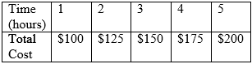  What does each company charge per hour?  Ace: _______  Base: _______ | The function c = 0.5m + 1 describes the cost c in dollars of a phone call that lasts m minutes made from a room at the Shady Tree Hotel. Graph the function.  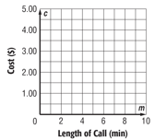  Use the graph to determine how much a 7 minute call will cost.  How much would a 25 minute call cost?
Mia has 3 times as many points as Jay. Jay has 20 fewer points than Mia. Write and solve a system of equations to find each players’ points. | If the area of a rectangle is 24, What is the value of x?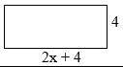
Homework: Tuesday, October 25, 2016
TRY YOUR BEST! SHOW ALL OF YOUR WORK! NO WORK! NO CREDIT!
WEIGHTS AND MEASURES:  One inch is 25.4 millimeters. Write 25.4 millimeters as a mixed number in simplest form. | EDUCATION: A local middle school has 47 computers and 174 students. What is the number of students per computer at the school? Write your answer as both a mixed number in simplest form and a decimal rounded to the nearest tenth.
Express the relation as a table and a graph.  {(2,0), (1,-1), (0,-2), (3,1), (4,2)}  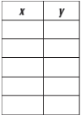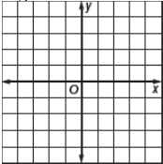 | x x + 48 f(x)  Strom works as a valet at the Westside Mall. He makes $48 per day and $1 for each car he parks. The amount of money Strom earns in one day can be found using the function, f(x) = x + 48, where x represents the number of cars that Strom parked. Make a function table to show the total amount Strom makes in one day if he parks 25, 30, 35, and 40 cars.
Homework: Wednesday, October 26, 2016
TRY YOUR BEST! SHOW ALL OF YOUR WORK! NO WORK! NO CREDIT!
What is the value of x in the equation:  y = ½ x - 6 | The perimeter of a rectangle is 36 meters. The length of the rectangle is 4 meters longer than the width. Find the length and width of the rectangle. (Draw a picture to help)
The equation y = 0.2x + 3.5 can be used to find the amount of snow accumulated snow y in inches x hours after 5 p.m. on a certain day. Identify the slope and y-intercept of the graph of the equation and explain what each represent. | 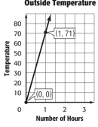  Chinook winds are warm dry winds that blow down the side of the mountain that causes drastic temperature changes. The graph shows the outside change from chinook winds after a number of hours.  In another location the temperature y after x hours can be represented by the function y = 68x. Compare the functions by comparing the temperatures.
Homework: Thursday, October 27, 2016
TRY YOUR BEST! SHOW ALL OF YOUR WORK! NO WORK! NO CREDIT!
Janette’s weekly salary can be represented by the equation y = 500 + 0.4x, where x is the dollar total of her sales for the week. Identify the slope and y-intercept of the graph of the equation and explain what each represent. | Courtney belongs to a health club that charges a monthly fee of $20, plus $85 to join. Write a function to represent her costs. How much has she paid after six months?
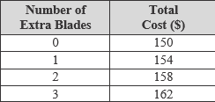  The table shows the total cost of a band saw and extra blades. Write an equation to find the total cost c with any number of extra blades e. Use the equation to find the cost of a band saw with 10 extra blades. | The graph shows a state’s minimum wage from 2005 to 2012. Would you describe the yearly increase as linear or nonlinear? Explain your reasoning.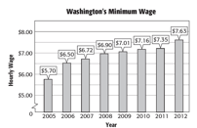
Function or not a function?
