Grade 8 Week 27 Name: __________________________
Homework: Monday, March 13, 2017
TRY YOUR BEST! SHOW ALL OF YOUR WORK! NO WORK! NO CREDIT!
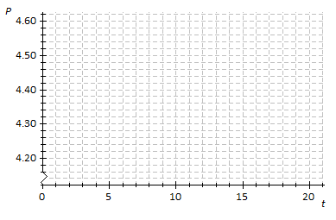
- Suppose that the price of gasoline has been falling. At the beginning of last month ($t=0$), the price was $\$4.60$ per gallon. Twenty days later ($t=20$), the price was $\$4.20$ per gallon. Assume that the price per gallon, $P$, fell at a constant rate over the twenty days.
Time in days
  - Identify the ordered pairs given in the problem. Plot both points on the coordinate plane above.
Price per Gallon in Dollars
  - Using a straightedge, draw the line that contains the two points.

  - What is the rate of change? What does it mean within the context of the problem?
Time in Days

  - What is the function that models the relationship between the number of days and the price per gallon?

  - What was the price of gasoline after $9$days?

  - After how many days was the price $\$4.32$?

What is the value of "t" in the equation 3(t- 4) = 2t + 1? | How many solutions to the equation 3y + 5 = 7 + 3y – 9
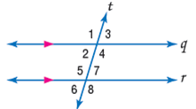  What is the relationship between the given angles ∠3 and ∠6?  - Corresponding  - Alternate interior  - Alternate exterior  - Consecutive | 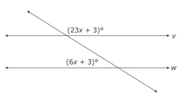  Lines v and w are parallel. What is the value of x?

Homework: Tuesday, March 14, 2017
TRY YOUR BEST! SHOW ALL OF YOUR WORK! NO WORK! NO CREDIT!
Identify the slope and y – intercept of each equation.  - $y=-x+9$  m = ________ b= _______  - $y=-\frac{2}{5}x-7$  m = ________ b= _______  - $y=7x+\frac{1}{4}$  m = ________ b= _______ | 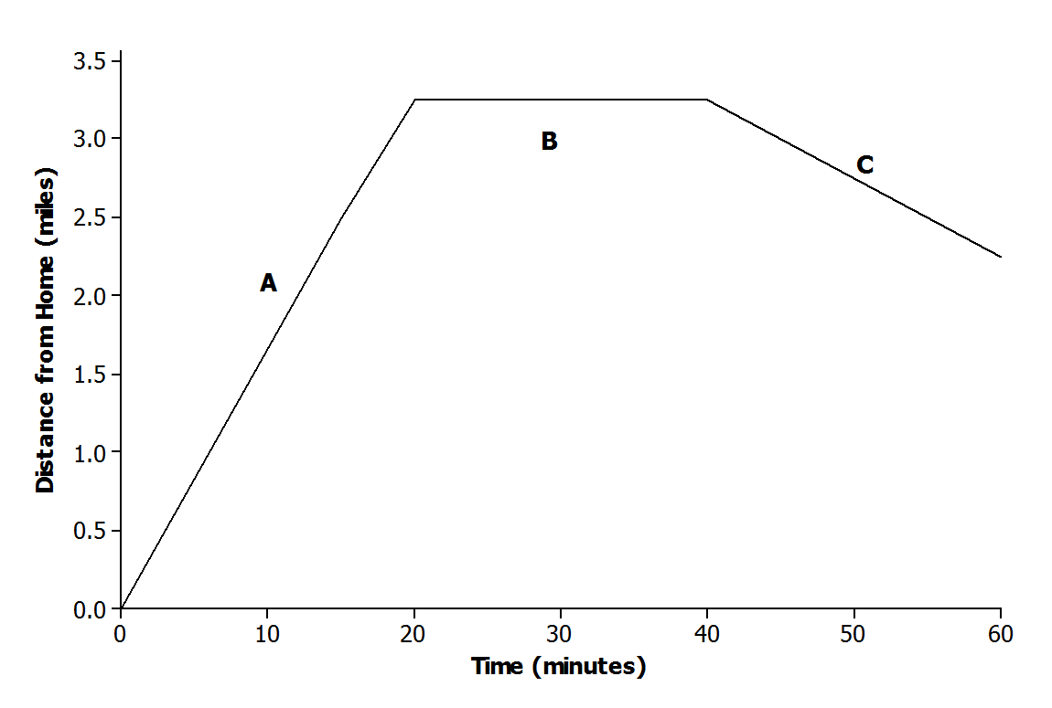  The graph below displays the first hour of Sam’s bike ride. Match each part of the graph (A, B, and C) to its verbal description. Explain the reasoning behind your choice.  - Sam rides his bike to his friend’s house at a constant rate.  - Sam and his friend bike together to an ice cream shop that is between their houses.  - Sam plays at his friend’s house.
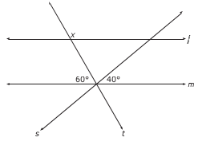  Lines l and m are parallel to one another and cut by transversals s and t. What is the value of x?  - 40°  - 80°  - 120°  - 140° | What is the relationship between the given angles ∠1 and ∠5?  - Corresponding  - Alternate interior  - Alternate exterior  - Consecutive
The vertices of KLM are K (1,2), L (3,1), and M (2,4). After a transformation of KLM to K’L’M’, the resulting points are K’ (3,6), L’ (9,3), and M’ (6,12). Which transformation results in this image?  - Translation of 3 units right and 3 units up.  - Translation of 2 units right and 4 units up.  - Dilation with a scale factor of 3.  - Dilation with a scale factor of $\frac{1}{3}$. | Write the equivalent fraction for 0$.\overline{52}$ x $\frac{2}{3}$
Homework: Wednesday, March 15, 2017
TRY YOUR BEST! SHOW ALL OF YOUR WORK! NO WORK! NO CREDIT!
An MP3 download site offers downloads of individual songs with the following price structure: a $\$3$fixed fee for a monthly subscription plus a fee of $\$0.25$ per song. Write an equation.  Find the total bill…  if you only wanted to download $5$ songs per month?  If you wanted to download $10$ songs? | Read through the scenarios, and sketch a graph of a function that models the situation.  A messenger service charges a flat rate of $\$4.95$ to deliver a package regardless of the distance to the destination.  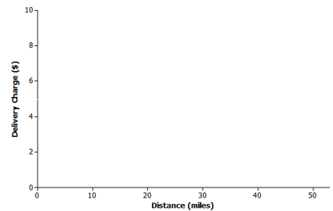
You go to the fair and it costs $5 to get inside. Then you buy 2 ticket booklets. You spent $25. How much did each booklet cost? | Solve for the variable: $4p+12=-p-4$
Write the equivalent fraction for 0$.5\overline{2}$ x $\frac{8}{9}$ | What is the relationship between the given angles ∠4 and ∠7?  - Corresponding  - Alternate interior  - Alternate exterior  - Consecutive
Triangle KLM will be dilated by a scale factor of 2.5. What will the area of the triangle K’L’M’?  - 10 unit²  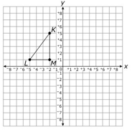  - 75 unit²  - 37.5 unit²  - 12.5 unit² | Solve for the variable:  $$-2y+16+6y-15= 4y + 1$$

Homework: Thursday, March 16, 2017
TRY YOUR BEST! SHOW ALL OF YOUR WORK! NO WORK! NO CREDIT!
Convert the following linear equations to slope intercept form. (y = mx + b)  $$-2x +12 =4y$$ | 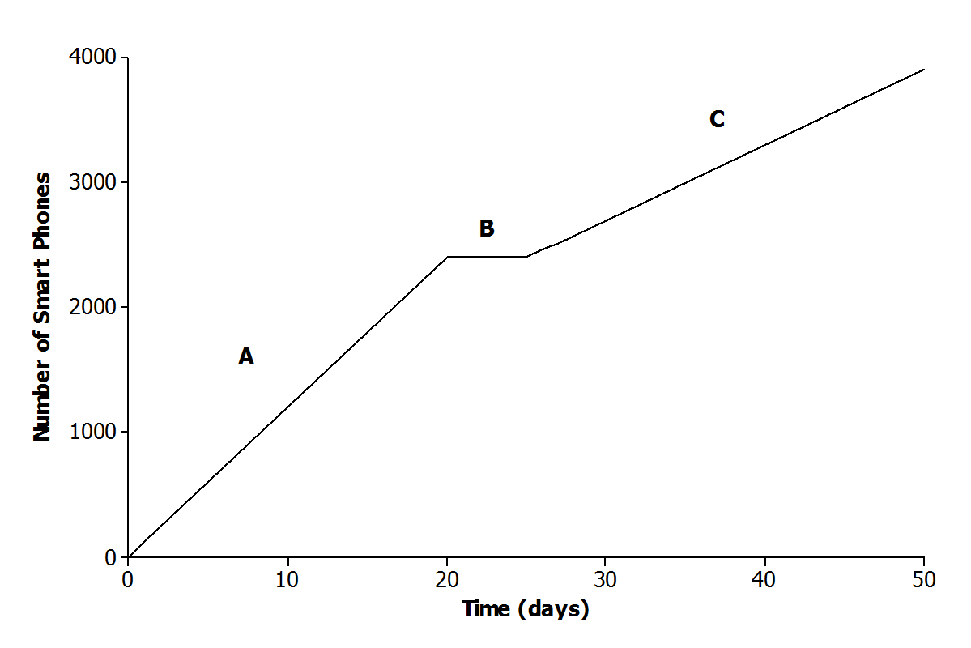  The graph below represents the total number of smartphones that are shipped to a retail store over the course of $50$ days. Which part of the graph (A, B, and C) matches the verbal description. Explain the reasoning behind your choice.  Half of the factory workers went on strike, and not enough smartphones were produced for normal shipments.
The equation 9 + 3a - 4 = a + 20 - 15 has infinitely many solutions. What value should be placed in the box?
The measures of the angles of a triangle are 50°, 35°, and 95°. What is the measure of the largest exterior angle of the triangle?  - 85°  - 130°  - 145°  - 150° | 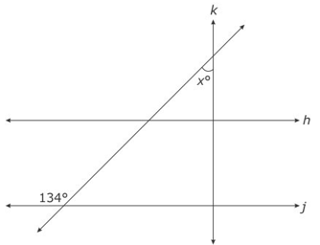  In the figure below, line k is perpendicular to line h. Lines h and j are parallel. What is the measure of angle x?  - 44°  - 45°  - 46°  - 47°
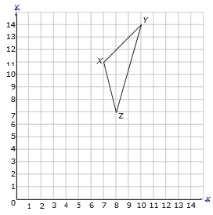
XYZ will be translated so that the coordinates of X’ are (5,11). What will be the coordinates of Z’?
- (5,8)
- (6,7)
- (7,6)
- (8,5)

