Grade 8 Week 24 Name: __________________________
Homework: Tuesday, February 21, 2017
TRY YOUR BEST! SHOW ALL OF YOUR WORK! NO WORK! NO CREDIT!
- Is π rational or irrational, and why?  - Since π can be represented as a fraction of two rational numbers, π is rational.  - Since π cannot be represented as a fraction of two rational numbers, π is rational.  - Since π can be represented as a fraction of two rational numbers, π is irrational.  - Since π cannot be represented as a fraction of two rational numbers, π is irrational. | What is the approximate value of √27?  - 3.0  - 5.2  - 9.0  - 13.5
List all the angles congruent to the given angle. Explain your reasoning.  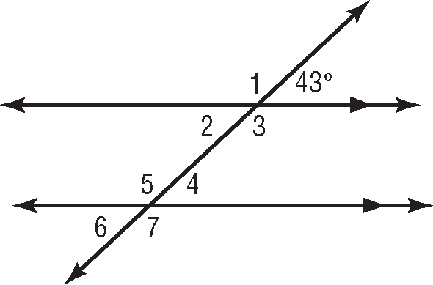  Determine the measurement for angle 5. Explain your reasoning. | What value completes the list of numbers in order from least to greatest? 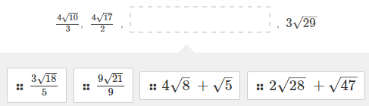
Which statement is true? 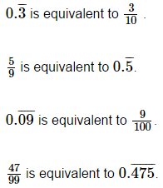 | List the following from least to greatest.  2.5, $\frac{9}{4}$, , $\frac{7}{3}$, √6
Homework: Wednesday, February 22, 2017
TRY YOUR BEST! SHOW ALL OF YOUR WORK! NO WORK! NO CREDIT!
The area of a square field is 625 square meters. What is the perimeter of the field?  - 312.5 C. 156.5  - 100 D. 25 | The diameter of a molecule is represented by 2.4 X 10⁻⁵. Which would be equivalent to its radius?  - 0.000048 C. 0.000012  - 0.000024 D. 0.0000024  Hint: 2r = d
The diameter of the sun is 1,391,000 kilometers.  Approximately, what is the sun’s diameter in miles written in scientific notation?  Use 1 mile = 1.6 kilometers.  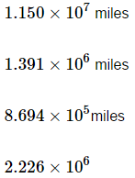 | 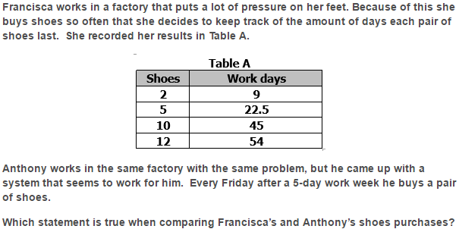  - Francisca buys 3 pairs of shoes every 15 work days  - Francisca buys one more pair of shoes than Anthony after a 9-week work period  - Francisca and Anthony buy shoes at the same rate  - Anthony gets 3 more days than Francisca from 4 pairs of shoes
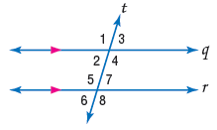  Classify each pair of angles as alternate interior, alternate exterior, or corresponding.  ∠3 and ∠6  ∠7 and ∠3  ∠5 and ∠4 | 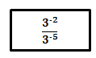  Four student solve the problem to the left.  Which student chose the correct method?  - Kathy: Keep the same base. Subtract -5 from -2, and the result is the new exponent. Next, simplify 3³. The simplified form is 27.  - Aaron: Keep the same base. Add -5 to -2, and the result is the new exponent. Next, simplify 3⁻⁷. The simplified form is $\frac{1}{2187}$.  - Eva: Keep the same base. Multiply -5 and -2, and the result is the new exponent. Next, simplify 3¹⁴. The simplified form is 4,782,969.  - Matthew: Keep the same base. Divide -5 by -2, and the result is the new exponent. Next simplify 3^{2.5}. The simplified form is 15.6.
Homework: Thursday, February 23, 2017
TRY YOUR BEST! SHOW ALL OF YOUR WORK! NO WORK! NO CREDIT!
How do you find the slope and y-intercept using the calculator? (List at least one way.) | Joe calculated the length of a support wire to be √60 feet long. Which statement is the best method to approximate the value of √60?  - Find the quotient of 60 and 2. The approximation of √60 is 60 divided by 2.  - Square 60 and divide the result by 2. The approximation of √60 is 60² divided by 2.  - Find two consecutive whole numbers with squares that are greater than and less than 60, respectively. The approximation of √60 is between these numbers.  - Find two consecutive whole numbers which are greater than and less than 60. Square them and average the result. The approximation of √60 is between the square of these numbers.
How do you find the solution to a system of equations using the calculator?
Study for CFA #3 Good Luck Tomorrow!!! You can do it!!! 80% or better!!!!

