Week 20 Name: __________________________
Homework: Monday, January 23, 2017
TRY YOUR BEST! SHOW ALL OF YOUR WORK! NO WORK! NO CREDIT!
Match the system of linear equations with the corresponding graph.  Use the graph to estimate the solution. Check your solution.  1. y = 3x − 2  y = 4x − 3  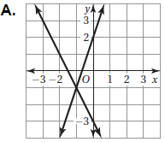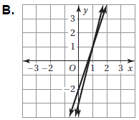 | In which function table do all of the points (x, y) lie on the line that has a slope of 3 and a y-intercept of 2? 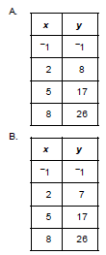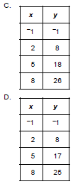
Which representation corresponds to the equation y = 3x + 1?
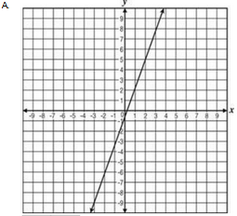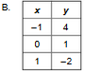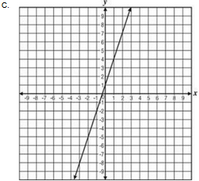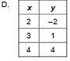

Homework: Tuesday, January 24, 2017
TRY YOUR BEST! SHOW ALL OF YOUR WORK! NO WORK! NO CREDIT!
Solve the system of linear equations by graphing.  a. y = −2x + 1 b. -18x + 3y = − 9  y = 2x − 3 8x - 2y = 2  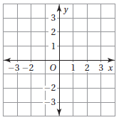 | Sally’s Lawn Service uses the equation,  y = 15x + 25 to calculate the cost, y, to work on a customer’s lawn for x number of hours. Ray’s Lawn Service uses the table below to calculate the cost to work on a customer’s lawn. If a customer requires 3 hours of lawn work, which lawn service charges less and by how much less?  Ray’s Lawn Service (Table)  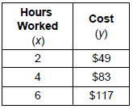  A. Sam’s Lawn Service charges $3.50 less for 3 hours of work.  B. Ron’s Lawn Service charges $3.50 less for 3 hours of work.  C. Sam’s Lawn Service charges $4 less for 3 hours of work.  D. Ron’s Lawn Service charges $4 less for 3 hours of work.

Homework: Wednesday, January 25, 2017
TRY YOUR BEST! SHOW ALL OF YOUR WORK! NO WORK! NO CREDIT!
What is the value of t in the equation  3(t − 4) = 2t + 1? | A hexagon has two sides that are equal. The two equal sides are 2 inches longer than each of the four other sides. The perimeter of the hexagon is 22 inches. What is the measure of one of the shorter sides?
Solve the system of linear equations by substitution. Check your solution.  y = x + 2  y = 3x − 4 | 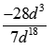  Simplify:

Homework: Thursday, January 26, 2017
TRY YOUR BEST! SHOW ALL OF YOUR WORK! NO WORK! NO CREDIT!
(FB.4) For a school group, a skating rink charges a flat fee of $50 for skates for the students, plus a charge per student to use the skating rink.  - For 40 students, the skating rink charges $180.  - For 75 students, the skating rink charges $293.75.  Which equation represents the amount the skating rink charges for x students?  A. y = 3.25x + 35 B. y = 3.25x + 50  C. y = 4.50x + 35 D. y = 4.50x + 50 | Solve the system of linear equations by substitution. Check your solution.  a. y = 3x + 4  x + y = 8
The area of a square ceiling tile is 576 square inches. What is the length of one edge of the tile? | Solve the system of linear equations by substitution. Check your solution.  b. −2x + 3y = 9  y = 2x + 7

