Week 15 Name: __________________________
Homework: Monday, December 5, 2016
TRY YOUR BEST! SHOW ALL OF YOUR WORK! NO WORK! NO CREDIT!
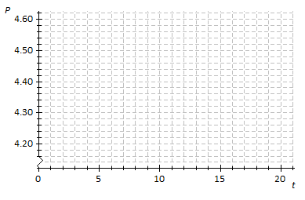
- Suppose that the price of gasoline has been falling. At the beginning of last month ($t=0$), the price was $\$4.60$ per gallon. Twenty days later ($t=20$), the price was $\$4.20$ per gallon. Assume that the price per gallon, $P$, fell at a constant rate over the twenty days.
Price per Gallon in Dollars
Time in days
  - Identify the ordered pairs given in the problem. Plot both points on the coordinate plane above.
  - Using a straightedge, draw the line that contains the two points.
  - What is the rate of change? What does it mean within the context of the problem?
Time in Days

What is the value of "t" in the equation 3(t- 3) = 4t + 1? | How many solutions to the equation 2y + 5 = -7 + 2y + 12
Homework: Tuesday, December 6, 2016
TRY YOUR BEST! SHOW ALL OF YOUR WORK! NO WORK! NO CREDIT!
Refer to #1 from last night’s homework.  - What is the function that models the relationship between the number of days and the price per gallon?  - What was the price of gasoline after $5$days?  - After how many days was the price $\$4.42$? | 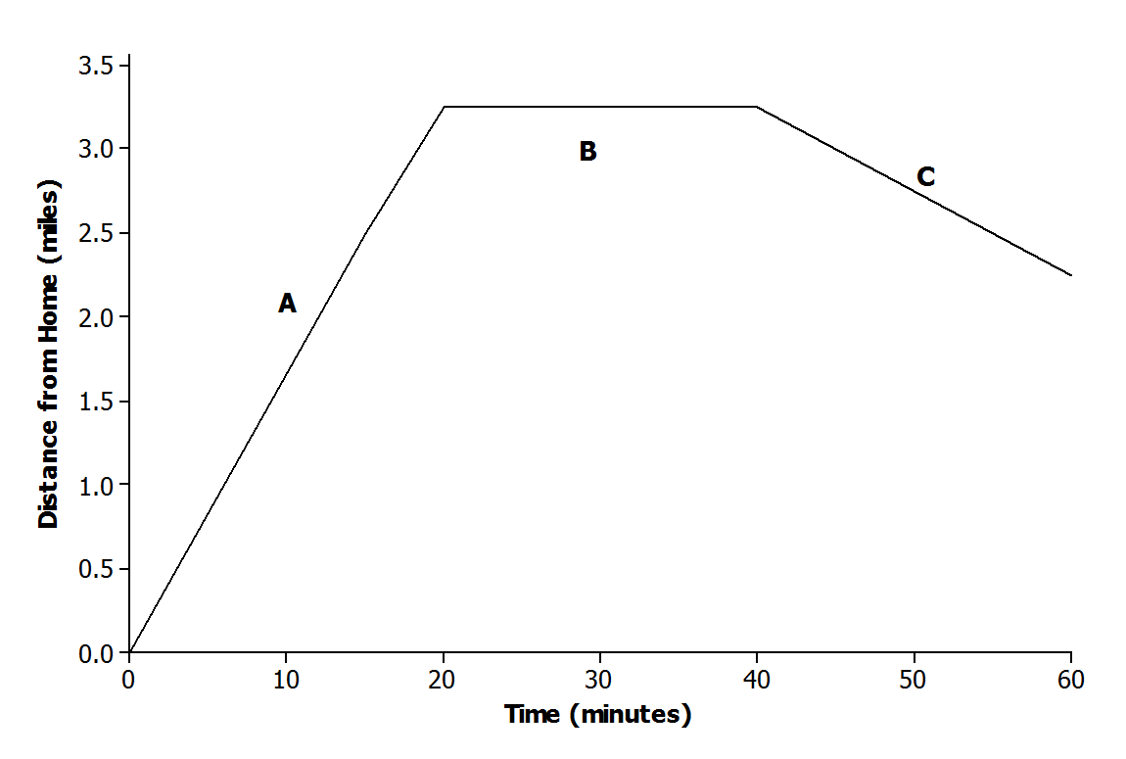  The graph below displays the first hour of Sam’s bike ride. Match each part of the graph (A, B, and C) to its verbal description. Explain the reasoning behind your choice.  - Sam rides his bike to his friend’s house at a constant rate.  - Sam and his friend bike together to an ice cream shop that is between their houses.  - Sam plays at his friend’s house.
Homework: Wednesday, December 7, 2016
TRY YOUR BEST! SHOW ALL OF YOUR WORK! NO WORK! NO CREDIT!
An MP3 download site offers downloads of individual songs with the following price structure: a $\$3$fixed fee for a monthly subscription plus a fee of $\$0.25$ per song. Write an equation.  Find the total bill…  if you only wanted to download $6$ songs per month?  if you wanted to download $15$ songs? | Read through the scenarios, and sketch a graph of a function that models the situation.  A messenger service charges a flat rate of $\$4.95$ to deliver a package regardless of the distance to the destination.  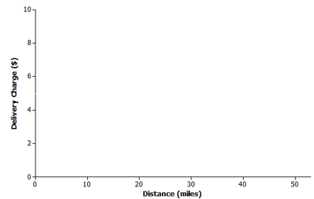
Write the equivalent fraction for 0$.5\overline{\overline{2}}$ x (7/9)
You go to the fair and it costs $5 to get inside. Then you buy 2 ticket booklets. You spent $25. How much did each booklet cost? | Solve for the variable: $4p+12=-p-4$  Convert the following linear equations to slope intercept form. (y = mx + b)  $$-2x +8 =4y$$
Homework: Thursday, December 8, 2016
TRY YOUR BEST! SHOW ALL OF YOUR WORK! NO WORK! NO CREDIT!
The equation 9 + 3a - 4 = a + 20 - 15 has infinitely many solutions. What value should be placed in the box? | 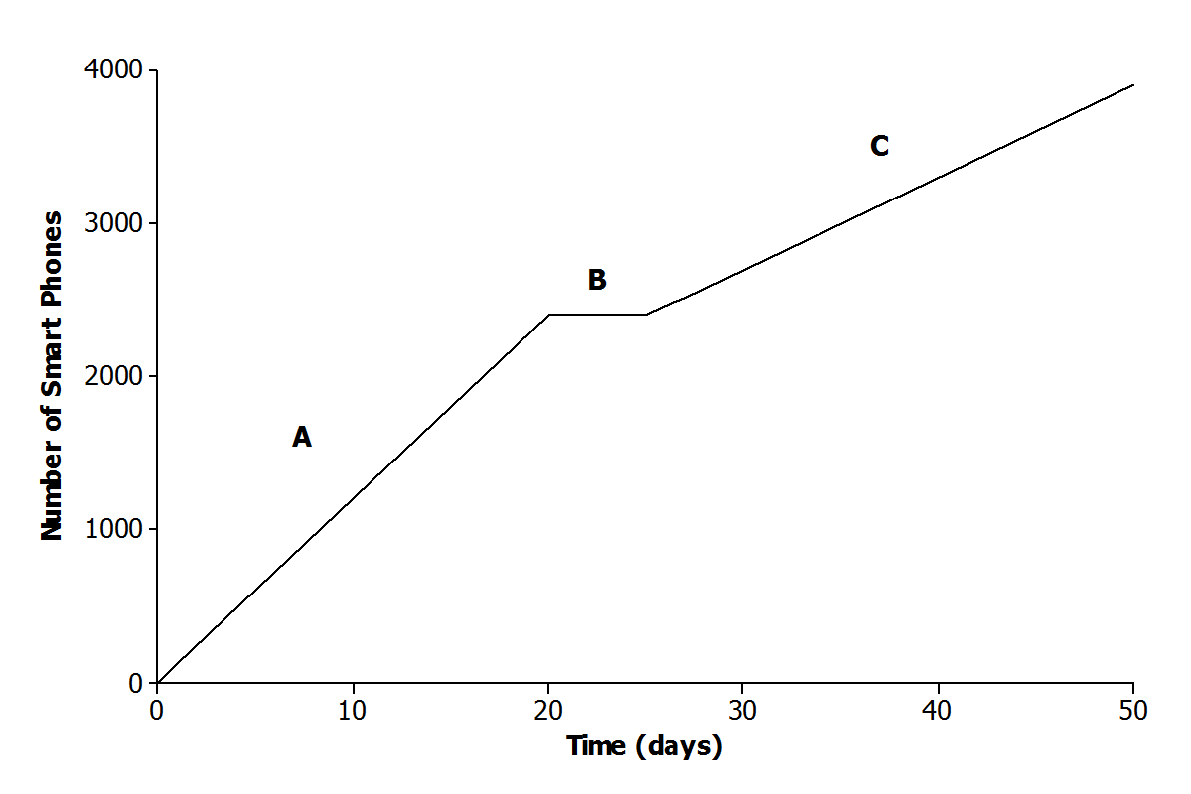  The graph below represents the total number of smartphones that are shipped to a retail store over the course of $50$ days. Which part of the graph (A, B, and C) matches the verbal description. Explain the reasoning behind your choice.  Half of the factory workers went on strike, and not enough smartphones were produced for normal shipments.
Solve the following system of equations graphically.
$$y=\frac{-1}{2}x$$
$$-2y=-x+4$$

