Week 23 Name: __________________________
Homework: Monday, February 13, 2017
TRY YOUR BEST! SHOW ALL OF YOUR WORK! NO WORK! NO CREDIT!
What is the slope of the line passing through these points?  (13, 6 ) and ( 3 , 1 )  (12, 2 ) and ( 12 , 16 )  (3, 2 ) and ( 12 , 2) | The beginning of a quilt is shown below. Look for a pattern in the quilt. Copy and translate the quilt square to finish the quilt.  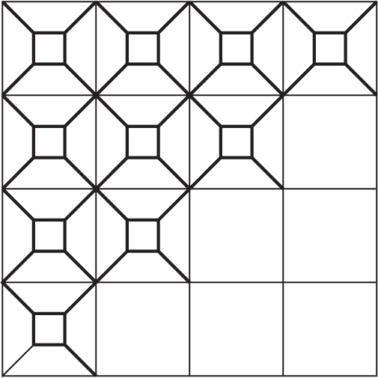
The workers at a plant drink 38 gallons of water per day. Write an equation to find the number of gallons g the workers drink in any number of days d.  _________  Use the equation to determine how many gallons of water the workers will drink in 30 days. ___________ | The figure shows the Oak Creek trail, which is shaped like a triangle. What is the value of x in the figure?  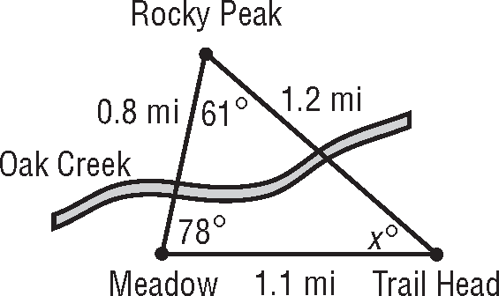
While at the music store, Drew bought 5 CDs, all at the same price. The tax on his purchase was $6, and the total was $61. What was the price of each CD? | Over the weekend, Koko spent 2 hours on an assignment, and she spent equal amounts of time studying for 4 exams for a total of 16 hours. How much time did she spend studying for each exam?
Homework: Tuesday, February 14, 2017
TRY YOUR BEST! SHOW ALL OF YOUR WORK! NO WORK! NO CREDIT!
Chet gets $12 per week as allowance. Write an equation to find the amount of allowance a Chet receives in any number of weeks. _______________  Make a table to find the amount of allowance Chet receives in 5, 6, 7, or 8 weeks.  Weeks, w Allowance, a | 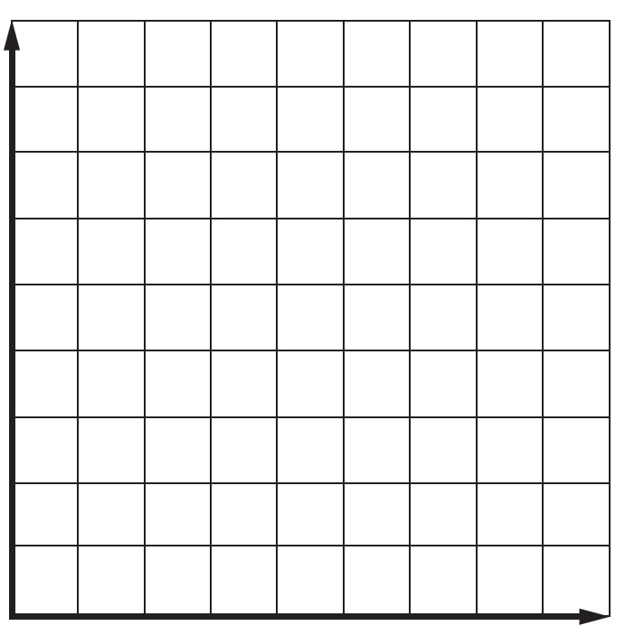  Graph the ordered pairs from question 1. Include your labels for weeks and $.
Draw the image of the figure after the indicated translation. 5 units right and 3 units down  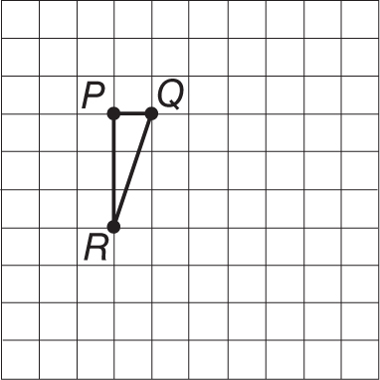 | Pasha is thinking of a number such that when twice the number is added to three times one more than the number she gets the same result as when she multiplies four times one less than the number. What number is Pasha thinking about?
Laura is making a patio in her backyard using paving stones. She buys 44 paving stones and a flowerpot worth $7 for a total of $73. How much did each paving stone cost? | Solve: SHOW EVERY STEP TO GET CREDIT  $$4a - 3(a - 2) = 2(3a - 2)$$
Homework: Wednesday, February 15, 2017
TRY YOUR BEST! SHOW ALL OF YOUR WORK! NO WORK! NO CREDIT!
- A triangular wall decoration on Kelsey’s wall has vertices M(4, –1), N(3, –4), and R(1, –2). The triangle is translated 5 units left and 4 units up.  Graph the decoration AFTER this translation.  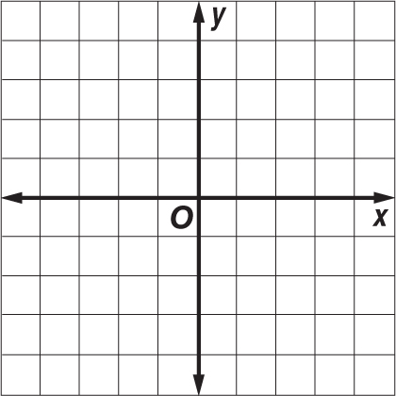 | Using the figure from question 1:  - What are the coordinates for M’?  - What are the coordinates for N’?  - What are the coordinates for R’?
The perimeter of an equilateral triangle equals 3 times the length of one side. Write a function using two variables for this situation. Find the perimeter of an equilateral triangle with sides 18 inches. | Jonah received $300 in cash gifts for his fourteenth birthday. The function y = 300 – 25x describes the amount y remaining after x weeks if Jonah spends $25 each week. Determine the amount remaining after 9 weeks using the equation, you MUST show your work.
Translate each sentence into an equation.  Seven more than the quotient of a number and 2 is 10.  Seven more than twice a number is 1. | Define a variable and then write and solve an equation to find each number.  Nine more than the quotient of a number and 4 is 12.  Nine less than six times a number is –15.
Homework: Thursday, February 16, 2017
TRY YOUR BEST! SHOW ALL OF YOUR WORK! NO WORK! NO CREDIT!
Find the coordinates of the figure after a dilation factor of 4. The graph the dilated figure.  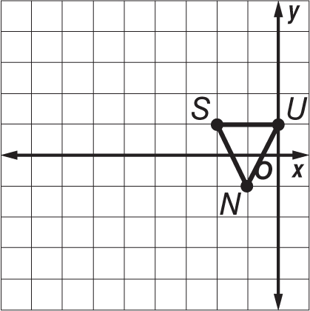  S(–2, 1), U(0, 1), N(–1, –1); k = 4 | Half of a design is shown below. Reflect the figure across the x-axis to obtain the completed design.  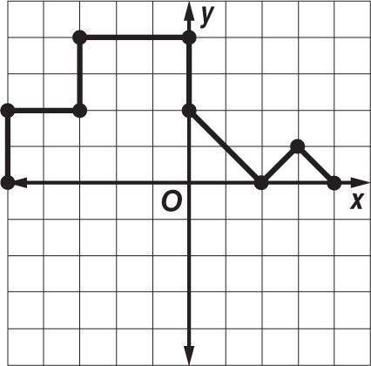
The number of students at Albemarle Road Middle School is 31 less than 2 times the number of students at Albemarle Road Elementary. Create an expression that represents the amount of students at ARMS._________________________  How many students are there if 800 students attend the elementary school? | Solve: SHOW EVERY STEP TO GET CREDIT  $$(7t - 2) - (-3t + 1) = -3(1 - 3t)$$
A taxi service charges you $1.50 plus $0.60 per minute for a trip to the airport. The distance to the airport is 10 miles, and the total charge is $13.50. How many minutes did the ride to the airport take?

