Name: __________________________
Homework: Monday, February 6, 2017
TRY YOUR BEST! SHOW ALL OF YOUR WORK! NO WORK! NO CREDIT!
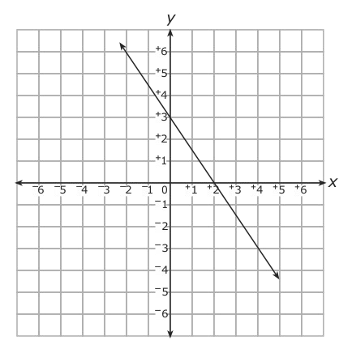  Which is an equation of the line graphed below?  - y = $\frac{-3}{2}$ x – 3  - y = $\frac{-3}{2}$ x + 3  - y = $\frac{3}{2}$ x – 3  - y = $\frac{3}{2}$ x + 3 | HUNTING Taro uses a coordinate system with units of feet to keep track of the locations of any objects he finds with his metal detector. One lucky day he found a ring at (5, 7) and an old coin at (10, 19). How far apart were the ring and coin before Taro found them? Round to the nearest tenth if necessary.
Sibling Account Balance  Cindy s  Petros 2(s + 3)  Nila 4s – 5  The table shows the savings account balance of each of the Alvarez siblings.  Write an equation to find the amount of money in Petro’s account if the total of all of their accounts is $148.  Solve the equation to find the amount of money in Petro’s account. | 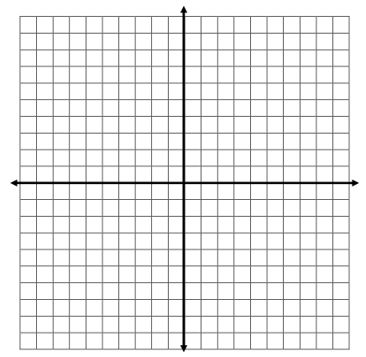  Bryce is looking at a map of a theme park. The map is laid out in a coordinate system. Bryce is at (2, 3). The roller coaster is at (7, 8), and the water ride is at (9, 1). Is Bryce closer to the roller coaster or the water ride?
Homework: Tuesday, February 7, 2017
TRY YOUR BEST! SHOW ALL OF YOUR WORK! NO WORK! NO CREDIT!
Gene sold 10 glasses of lemonade while setting up his lemonade stand. After opening, he sold an average of 20 glasses each hour. Write a function to represent the approximate number of glasses g(h) sold after h hours. About when did he sell the 100th glass of lemonade? | The coordinates of points A, B, and C are (5, 4), (–2, 1), and (4, –4), respectively. Which point, B or C, is closer to point A?
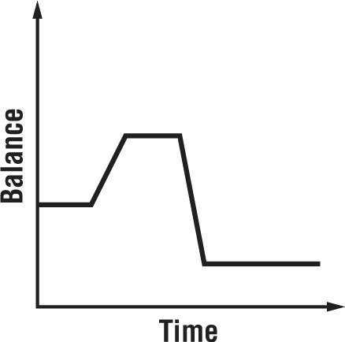  The graph below shows the amount of money in the Soccer Club’s account. Describe the change in balance over time.  x 3x + 5 f(x) | Audrey has $120 to spend on a tennis racket and lessons. The racket costs $45 and the lessons cost $15 per hour. Define a variable. Then write and solve an equation to find how many hours of lessons she can afford.
Homework: Wednesday, February 8, 2017
TRY YOUR BEST! SHOW ALL OF YOUR WORK! NO WORK! NO CREDIT!
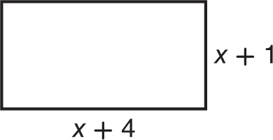  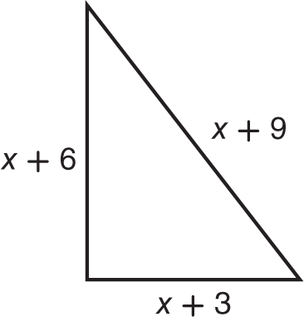  Write an equation to find the value of x so that each pair of polygons has the same perimeter. Then solve. | A one-year membership to a gym costs $725. The registration fee is $125, and the remaining amount is paid monthly. Define a variable. Then write and solve an equation to find how much new members pay each month.
Homework: Thursday, February 9, 2017
TRY YOUR BEST! SHOW ALL OF YOUR WORK! NO WORK! NO CREDIT!
Solve each equation and CHECK YOUR ANSWER:  $4a - 3(a - 2) = 2(3a - 2)$ | Determine whether the relationship between the two quantities in each table is linear. If it is, find the constant rate of change.  Time (min) Temperature (°F)  9 60  10 64  11 68  12 72  Hours Spent Babysitting Money Earned ($)  1 10  3 30  5 50  7 70
Solve each equation and CHECK YOUR ANSWER:

$5(x - 3) + 2x = 41$

Solve each equation and CHECK YOUR ANSWER:

$14 - 2(3p + 1) = 6(4 + p)$

How MANY solutions do these equations have? One, none, infinitely many?

3(x+7) = 3x + 11 -2(x + 3) = -2x – 6

Graph the function y = x -4 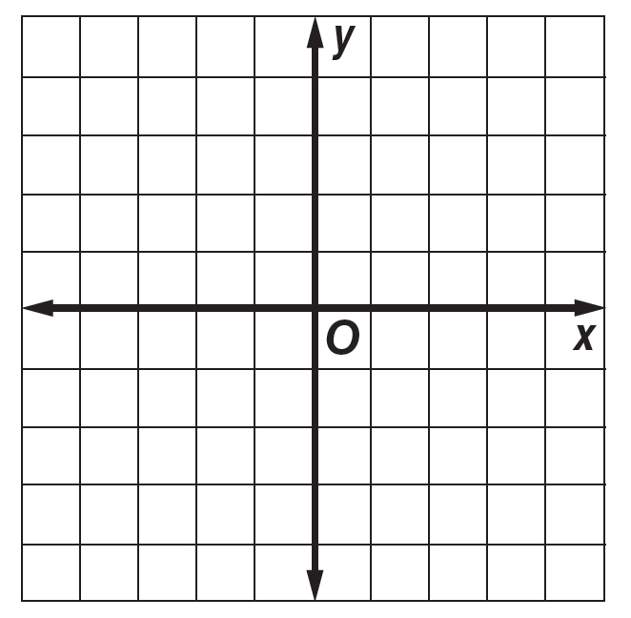 | Graph the function  y = ¼ x + 2

