Week 21 Name: __________________________
Homework: Monday, January 30, 2017
TRY YOUR BEST! SHOW ALL OF YOUR WORK! NO WORK! NO CREDIT!
Convert the following equations from standard form to slope-intercept form.  a) 6x – 2y = 8 b) x + 8y = 16 | Find the value of x and y in the solution to the system of equations.  3x + 4y = 2  9x – 2y = 4
Find the value of two numbers if their sum is 18 and their difference is 4. Write and solve using a system of equations and the substitution method. SHOW YOUR WORK. | Sarah bought 25 t-shirts and shorts and spent a total of $ 200. If each t-shirt costs $5 and each pair of shorts cost $10, how many pairs of shorts did she buy?
Homework: Tuesday, January 31, 2017
TRY YOUR BEST! SHOW ALL OF YOUR WORK! NO WORK! NO CREDIT!
Solve this system.  4x – 3y = 8  2x + y = 11  What is the value of y?  a. 14  b. -6  c. 14/5  d. 8/3 | 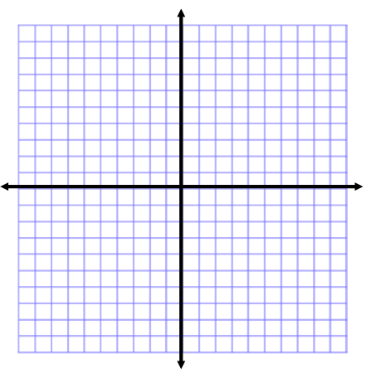  Solve the system by graphing.  3x + y = 10  -2x + 2y = 12  x =  y =  Solution  ( , )
Find the value of x and y in the solution to the system of equations.  2x – 3y = 5  -x + 2y = 6 | The total cost of 2 bracelets and 3 necklaces is $15.50. The total cost of 4 bracelets and 1 necklace is $13.50. This situation can be represented by the system below.  2b + 4n = 15.50  4b + n = 13.50  What is the cost of one bracelet?  a. $2.50  b. $3.50  c. $5.00  d. $7.75
Homework: Wednesday, February 1, 2017
TRY YOUR BEST! SHOW ALL OF YOUR WORK! NO WORK! NO CREDIT!
Find the value of x and y in the solution to the system of equations.  - 4x + 3y = 7  3x + 5y = 8  - 4x + y = 8  5x + 2y = 13 | A class of 300 students went on a field trip. The group took 14 vehicles, some buses and some vans. Find the number of buses and the number of vans they took if each bus holds 54 students and each van holds 16 students.
Find the value of two numbers if their sum is 39 and their difference is 11. | Estimate the solution to the equation to the nearest integer.  $d^{2}$ = 61  $z^{2}$ = 85
Estimate to the nearest integer:  $\sqrt{38}$ $\sqrt[3]{26}$ $\sqrt{99}$ | Solve the systems below using any method you choose:  a) x – y = 3  3x + y = 1  b) 2x + y = -5  2x + 6y = 50
Homework: Thursday, February 2, 2017
TRY YOUR BEST! SHOW ALL OF YOUR WORK! NO WORK! NO CREDIT!
The formula for the area of a square is A = s², where s is the length of a side. Estimate the length of a side for each square.  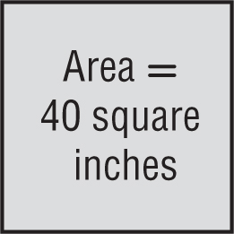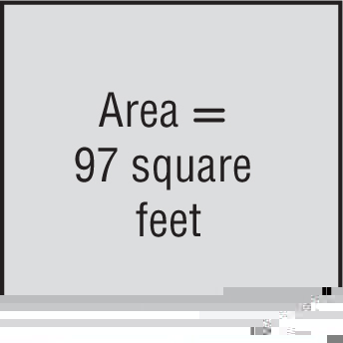 | Find the value of x and y in the solution to the system of equations.  - y = 2x – 8  7x + 3y = 15  - x + y = 3  y = x + 5  - 7x + 6y = -9  y = -2x + 1  - y = -3x + 2  6x + 2y = 1
Name all sets of numbers to which the real number belongs. (rational, irrational, whole, integer)

-9 $-\sqrt{44}$ 9.55

