Homework: Monday, October 17, 2015
TRY YOUR BEST! SHOW ALL OF YOUR WORK!
Determine whether the relationship between the two quantities described in each table is linear. If so, find the constant rate of change. If not, explain your reasoning.  Greeting Cards  Number of Cards Total Cost($)  1 1.50  2 3.00  3 4.50  4 6.00  Running  Time (min) Distance(mi)  15 2  30 4  45 5  60 6 | Humpback whales are known to weigh as much as 8 × 104 pounds. The tiny krill they eat weigh only 2.1875 × 10-3 pounds. How many times greater than krill are humpback whales?
 | If the area of a square is 81 square meters, how many meters long is each side?
 | Jodie took measurements of her new favorite jewelry box. Order the set of measurements from least to greatest. {2.2. 2$\frac{1}{5}$, √5, 2.222…}
REVIEW: The pull of gravity on the surface of Mars is 0.38 that of Earth. Write 0.38 as a fraction in simplest form. | REVIEW: In the first round of a local tennis tournament, there are 2⁵ matches. Find the number of matches.
Homework: Tuesday, October 18, 2016
TRY YOUR BEST! SHOW ALL OF YOUR WORK!
The Statue of Liberty is about 1.5108 × 10² feet tall from the base to the torch. The pedestal is 1.54 × 10² feet tall. How tall is the Statue of Liberty from the foundation of the pedestal to the top of the torch? | Determine whether a proportional relationship exists between the two quantities shown in each graph. Explain your reasoning.  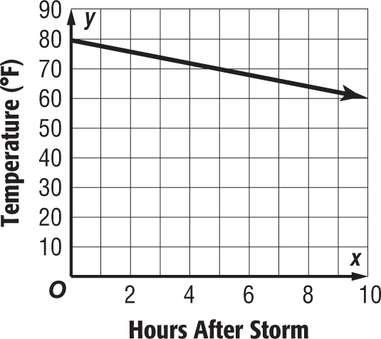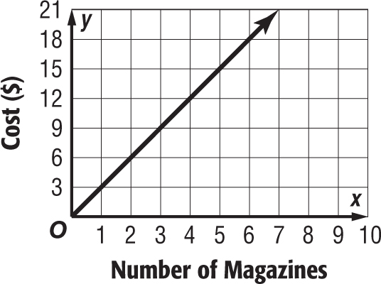
Jake is buying grass seed. The two pound bag will cover 100 square feet of lawn. Estimate the side length of the largest square Jake could seed if he purchases 4 bags. | A cube shaped packing box can hold 729 cubic inches of packing material. Solve 729 = s³ to find the length of one side of the box.
REVIEW: Evaluate  5⁵ ・ 6³ ・ 8¹⁰  5³ ・ 6 ・ 8⁹ | REVIEW: A company has set aside 10⁷ dollars for annual employee bonuses. If the company has 10⁴ employees and the money is divided equally among them, how much will each employee receive?

Homework: Wednesday, October 19, 2016
TRY YOUR BEST! SHOW ALL OF YOUR WORK!
The relation (0, 2), (3, 11), (x, 17), (8, 26) and (12, 38) is a function. What is the value of x? | Charmaine and Aaron are having a debate. Charmaine thinks the answer to their math homework is (4²)⁴, but Aaron says the answer is (4⁴)². Explain how both Charmaine and Aaron can be correct.
Evaluate and express your answer in scientific notation. | Give a counterexample for the statement “All square roots are irrational numbers”. Explain your reasoning.
REVIEW: Dedra’s dog weighs 5 x 2⁴ pounds. What is the weight of Dedra’s dog? | REVIEW: Simplify [(7²)²]²
Homework: Thursday, October 20, 2016
TRY YOUR BEST! SHOW ALL OF YOUR WORK!
A bank starts the day with 2.93 × 10⁴ dollars in the vault. At the end of the day, the bank has 3.5 × 10⁵  dollars in the vault. How much more money is in the vault at the end of the day than there was in the morning? | A concert crew needs to set up some chairs on the floor level. The chairs are to be placed in a square pattern consisting of four square sections. If one of the square sections hold 900 chairs, how many chairs will be along each length of the larger square?
Determine whether 1.2 x 10⁵ or 1.2 x 10⁶ is closer to one million. EXPLAIN.  coefficient | # of weeks Miles Ran  3 90  5 150  8 240  Jaquara and Lilly are both training for a race. The equation y = 25x represents the number of miles Lilly ran after x weeks. The table below represents the total miles Jaquara ran over a different number of weeks.
Moesha has 196 pepper plants that she wants to plant  in square formation. How many pepper plants should she plant in each row? | Estimate the square root:  - $\sqrt{97}$  - $√$145
REVIEW: Evaluate:  (9.8 × 10⁵) – (6.7 × 10³)  3.936 × 10⁵  2.4 × 10² | REVIEW: Nuclear power provided 78% of the energy used in France in 2005. Write 0.78 as a fraction in simplest form.

