Name: __________________________
Homework: Monday, January 16, 2017 MLKDay
TRY YOUR BEST! SHOW ALL OF YOUR WORK! NO WORK! NO CREDIT!
Simone planted a tomato plant and measured its height weekly. The total height at 2, 3, 4, and 5 weeks respectively were 13, 16, 19, and 22 inches tall. How tall was the tomato plant when Simone planted it? Assume the relationship is linear.  The cost of having photos taken includes a sitting fee and $12 for each portrait. The cost of 3, 6, and 9 photos respectively is $51, $87, and $123. What is the sitting fee?  For every computer sold, Kendall receives $250 in commissions. The amount of commissions that Peter receives can be represented by the function y = 255x where y is his commissions and x is the number of computers sold. How much more does Kendall receive in commissions than Peter if they both sell 5 computers? | The speeds of a coyote and giraffe are shown in the graph and table below. Compare the functions by comparing the rates of change.  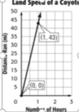  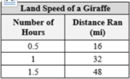  How much further does a coyote run than the giraffe after 3 hours?
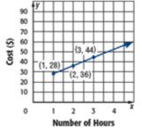  The graph shows the total cost for a lawn mowing service to mow a lawn. Find and interpret the rate of change and the initial value. | 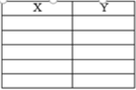  Create a function table that represents y = 4x + 2.  What is the domain?  What is the range?  What is the slope?  What is the y-intercept?
Homework: Tuesday, January 17, 2017
TRY YOUR BEST! SHOW ALL OF YOUR WORK! NO WORK! NO CREDIT!
Function or not a function?  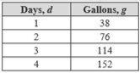  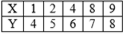 | 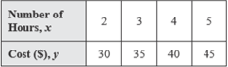  Write an equation to represent the relationship shown:
Miki has a square rug in her living room that has an area of 19 square yards. Estimate the length of a side of the rug to the nearest whole number.  Solve for x:  - $\sqrt[3]{x}$ = -5  - $x^{3}$ = -216 | A store made $2220 selling two styles of running shoes. Style A sold for $70 per pair and Style B sold for $90 per pair. The store sold a total of 28 shoes. How many of each style were sold?
Homework: Wednesday, January 18, 2017
TRY YOUR BEST! SHOW ALL OF YOUR WORK! NO WORK! NO CREDIT!
What is the value of x in the system of equations:  8x + 4y = 20  y = ½ x - 6 | The perimeter of a rectangle is 36 meters. The length of the rectangle is 4 meters longer than the width. Find the length and width of the rectangle. (Draw a picture to help)
The equation y = 2x + 3.5 can be used to find the amount of snow accumulated, y, in inches x hours on Groundhog’s day. Identify the slope and y-intercept of the graph of the equation and explain what each represent.  Courtney belongs to a health club that charges a monthly fee of $20, plus $85 to join. Write a function to represent her costs. How much has she paid after six months? | Solve the system by graphing.  y = 2x + 4  3x + y = 9
Homework: Thursday, January 19, 2017
TRY YOUR BEST! SHOW ALL OF YOUR WORK! NO WORK! NO CREDIT!
Write an equation in slope-intercept form for each line:  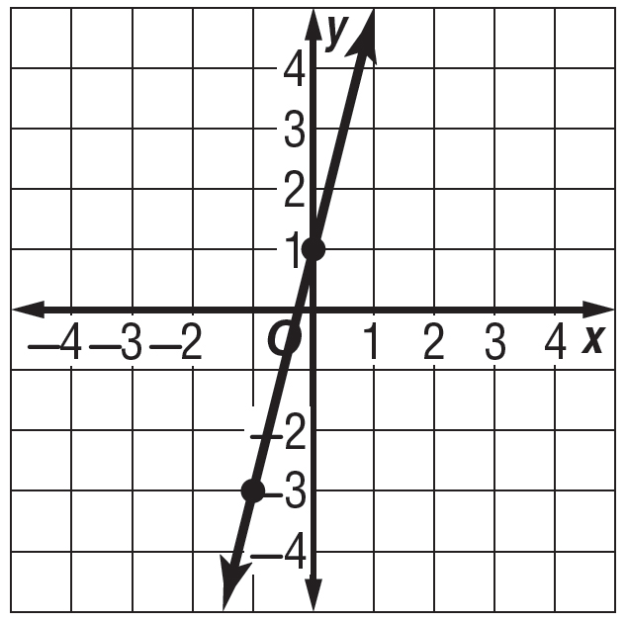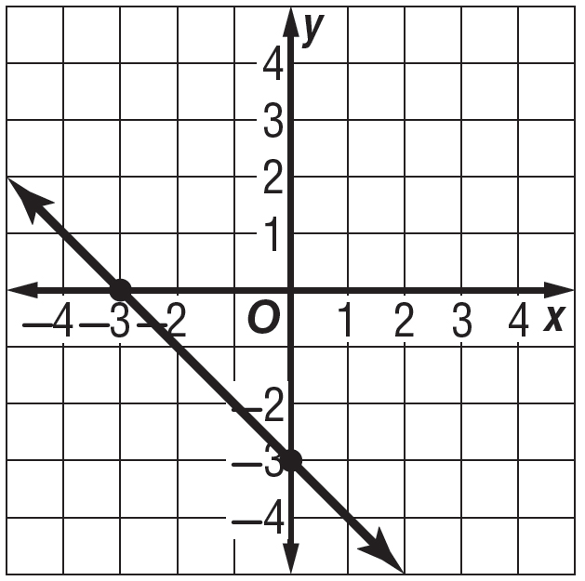 | Water accounts for about 60% of a person’s body weight. Write an equation that represents the water weight (y) of a person that weights (x) pounds.  Equation:  Make an input-output table for this equation and use the inputs 100, 120, 140, and 160.  X (weight) Y(water weight)  100  120  140  160
Bryson and Lily played a game of darts, and Lily scored 4 more points than Bryson. The total of their scores was 180. How many points did each of them score?  Jack bought x picks costing $30 each and y shovels costing $40 each. In all he spent $240. Write a function to represent the situation. | The cost for one ticket to a jazz concert is $7.50. Two tickets cost $15. Write an equation in slope intercept form to represent the total cost y for x tickets.  The total cost of renting a vacation home includes a deposit and a daily rental fee of $125. A family rents a vacation home for 5 days and pays $700. Assume the relationship is linear. Find and interpret the rate of change and the initial value. Write n equation.

