Name: __________________________
Homework: Monday, September 19, 2015
TRY YOUR BEST! SHOW ALL OF YOUR WORK! NO WORK! NO CREDIT!
COMPUTERS The byte is the fundamental unit of computer processing. The byte is based on powers of 2, as shown in the table. How many times greater is a gigabyte than a megabyte?  Memory Term Number of Bytes  byte $2^{0}$ or 1  kilobyte $$2^{10}$$  megabyte $$2^{20}$$  gigabyte $$2^{30}$$ | What is the best approximation for $\sqrt{38}$ ?  Simplify the following expression: $3\sqrt{100}+45$
Simplify  a. $7$⁻² b. 8⁰  c. ${(-5)}^{-5}$ d. $3^{-2}$ | Is -33 a rational number? Which Real Number set(s) does it belong to?

Homework: Tuesday, September 20, 2016
Write the equivalent fraction to the following:  0$.1\overline{23}$ | TEST The teacher marked Silvano’s problem wrong on his test.  $${{(4}^{5})}^{4}=4^{9}$$  Explain what he did wrong and give the correct answer.
Simplify.  a. ${({6t}^{5})}^{2}$ b. ${({4w}^{9})}^{4}$  c. ${({12k}^{6})}^{3}$ d. ${({15m}^{8})}^{3}$ | Simplify  e. $2^{-6}•2^{3}$ f. $s^{-5}•s^{7}$  g. $\frac{m^{8}}{m^{-4}}$ h. $\frac{{10}^{8}}{{10}^{9}}$
Homework: Wednesday, September 21, 2016
TRY YOUR BEST! SHOW ALL OF YOUR WORK! NO WORK! NO CREDIT!
CRAFTS Numa loves beads and wants to know which amount would be more, a thousand beads or ${{(6}^{2})}^{3}$ beads? | GAMING A video-game designer is using the expression ${6n}^{3}$ in a program to determine points earned, where n is the game level. Simplify the expression for the $n^{2}$ level.
Write the equivalent fraction to the following:  $$.4\overline{53}$$ | Simplify  a. ${(\frac{3}{5}a^{6}b^{9})}^{2}$ b. ${({4x}^{2})}^{3}{({3x}^{6})}^{4}$  c. ${({0.6p}^{5})}^{3}$ d. ${(\frac{1}{5}w^{5}x^{3})}^{2}$
Homework: Thursday, September 22, 2016
TRY YOUR BEST! SHOW ALL OF YOUR WORK! NO WORK! NO CREDIT!
Simplify using only positive exponents.  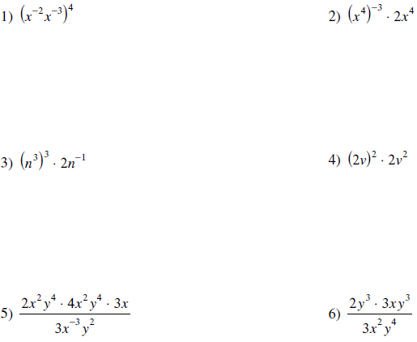 | TRAVEL The formula s $=\sqrt{18d}$ can be used to find the speed s of a car in miles per hour when the car needs d feet to come to a complete stop after slamming on the brakes. If it took a car 12 feet to come to a complete stop after slamming on the brakes, estimate the speed of the car.
Order from least to greatest.  a. 8, 10, $\sqrt{61}$, $\sqrt{71}$ b. $\sqrt{45}$, 9, 6, $\sqrt{63}$ | Simplify  a. ${({4d}^{3}e^{5})}^{7}$ b. ${({-4r}^{6}s^{15})}^{4}$  c. ${[{(7^{2})}^{2}]}^{2}$ d. ${[{(3^{2})}^{2}]}^{3}$

