Week 10 Name: __________________________
Homework: Tuesday, November 1, 2016
TRY YOUR BEST! SHOW ALL OF YOUR WORK! NO WORK! NO CREDIT!
Determine whether the graph for the following shows a positive, negative, zero, or no slope.  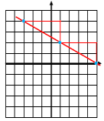 | What is the range of relation: (1,9), (-3, 5), (5, 11), (-6, -7)  Range: { }  What is the domain?  Domain: { }
Determine the slope of the graph for the following. | Ms. Barbour is purchasing balloons for a party for her mom’s birthday. Each spherical balloon is inflated with helium. How much helium is in the balloon if the balloon has a radius of 9 centimeters? Round to the nearest tenth. ____________  Express your rounded answer to the previous question in scientific notation.  ___________________

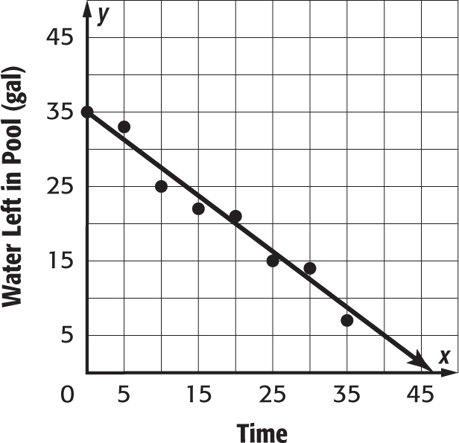
Cleo’s baby pool has a leak. The scatter plot shows the amount of water left in the pool at the end of each 5-minute segment. Write an equation in slope-intercept form for the line that is drawn.
_____________
Use the equation you wrote in problem one to make a conjecture about the amount of water left in the pool after 40 minutes. ___________

Homework: Wednesday, November 2, 2016
TRY YOUR BEST! SHOW ALL OF YOUR WORK! NO WORK! NO CREDIT!
Solve each equation and CHECK YOUR ANSWER:  $5(x - 3) + 2x = 41$ x =  $4a - 3(a - 2) = 2(3a - 2)$ a = | Identify the slope and the y-intercept:  2x – 3y = 6 slope = ___ y-int = ___
Homework: Thursday, November 3, 2016
Videl watched 6 times as many hours of television over the weekend as Dineen. Together they watched a total of 14 hours of television. How many hours of television did each person watch over the weekend? Write and solve a system of equations that represents this situation. You can use substitution or graphing. | The function d = 18g describes the distance d that Rick can drive his truck on g gallons of gasoline. Graph this function. Why is it sufficient to graph this function in the upper right quadrant only? How far can Rick drive on 2.5 gallons of gasoline?  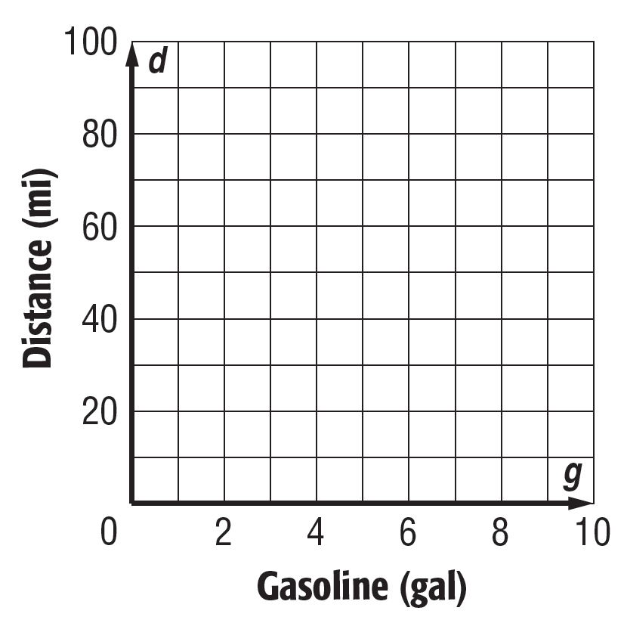
What is the value of 0.$\overline{36 }$· $\frac{11}{2}$ ?(Hint: Turn the repeating decimal into a fraction first.) | Identify the slope and the y-intercept:  y = 1/2x -3 slope= ___ y-int= ___  2x – 3y = 6 slope = ___ y-int = ___  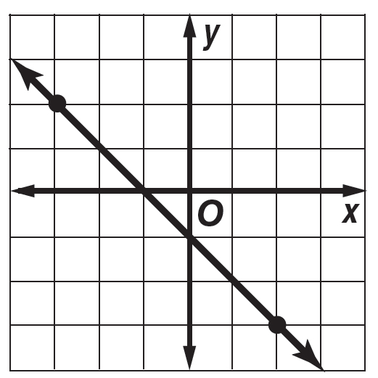 slope = ___ y-int = ___

