Homework: Monday, September 12, 2016
Solve the following problems. You MUST show your work. NO WORK = NO CREDIT
Using the number line, evaluate the expression below.
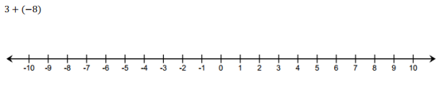

Write a word problem to go along with the expression  -10 + 3 | If a = -4, b = 5, and c = -6, which is larger  A. a + b  B. b + c  C. c + |a|

Homework: Tuesday, September 13, 2016
Solve the following problems. You MUST show your work. NO WORK = NO CREDIT
Your parents deposit $30 in your lunch account on Sunday night. On Monday, Tuesday, and Wednesday, you spend $7 on lunch, each day. Your parents put another $10 in your lunch account on Wednesday night. If you spend the same amount of money on lunch on Thursday and Friday, will you have enough money in your account to make it through the rest of the week?
Simplify the expression  -20 + (3 – 4) | Simplify the expression  (-18 + 3) – |-4|
Simplify the expression  - 4 + |-10| | Simplify the expression  -15 + (5 – 10)
Homework: Wednesday, September 14, 2016
Solve the following problems. You MUST show your work. NO WORK = NO CREDIT
Find the product:  (-6) x (13) | Find the quotient:  (135) ÷ (-3)
- John solved the following problem.  (-21) x (-4) = -84  Find his mistake and correct it. | Kimberly solved the following problem.  (128) ÷ ( -4) = -32  Is she correct? Explain why or why not?
It was a very freaky weather day. The temperature started out at $6℃$ in the morning and dropped to $-13℃$ at noon. It stayed at that temperature for six hours and then rose $8℃$. How far below the freezing point ($0℃$) was the temperature at 6 PM? | Morgan and Hiroshi are solving 24 + (-36). Find their mistakes, if any, and correct them.  Morgan  24 + (-36) = 24 + 36  = 60  Hiroshi  24 + (-36) = 24 - 36  = 12
Homework: Thursday, September 15, 2016
Solve the following problems. You MUST show your work. NO WORK = NO CREDIT
Simplify the expression  $$\left|-3+4-\left(-7\right)\right|$$ | Ms. Johnson writes the following expression:  (4) * (-3) * (-5) = -60  Is this a true statement? If not, rewrite the expression correctly and explain her mistake.
The temperature dropped from 35 degrees to -4 degrees in Piedmont, North Dakota in January within 2 hours. By how many degrees did the temperature change? | What is the unit rate of a person who drives 216 miles in 4 hours?  ________________ miles/hour

