Week 9 Name: __________________________
Homework: Monday, October 21, 2016
TRY YOUR BEST! SHOW ALL OF YOUR WORK! NO WORK! NO CREDIT!
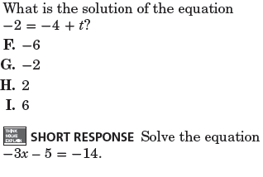 | Simplify for the variable:  - $-15+y -4y- 31$  - $-5(c- 2)$
Distribute.
4(p + 5)
Homework: Tuesday, October 22, 2016
Factor out the GCF.  - $8n + 24$  - $3n + 59$ | Simplify each expression.  6p + 14 + 3p  5(r – 10)  6(r + 12)
The distance between Little Rock and Benton is 24 miles. That is triple the distance between Little Rock and Maumelle. What then is the distance between Little Rock and Maumelle? | How many solutions does the equation have? (MUST SHOW WORK FOR CREDIT)  4x + 16  4(x – 4)

Homework Wednesday October 23, 2016
- 4 + 3P= 19 2. -6K - 13= 83

3 17 ( X + 5) = 0 4. 9 ( 3 + 5)=

5 Maureen bought a coat. She was excited because it was on sale, so she paid $15.25 less than the original price. She paid $48.75 for the coat. Write and solve an equation to determine the original price. Let p represent the original price.

Homework Thursday October 24, 2016

- 5X + 3= 8 2. -6 - 2M= 10

3 -5= 7 + 3R 4. M + 15= 24

5. Itʼs getting cold outside! The temperature dropped steadily at a rate of about 4 degrees every hour. If the temperature dropped a total of 22 degrees, how many hours have passed? Let h represent the number of hours

