Grade 7 Week 24 Name: __________________________
Homework: Tuesday, February 21, 2017
TRY YOUR BEST! SHOW ALL OF YOUR WORK! NO WORK! NO CREDIT!
- 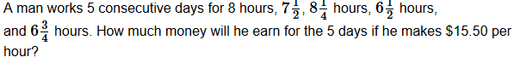 | 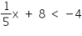  Which of the following will be included in the solution to the inequality?  - -58  - -59  - -60  - -61
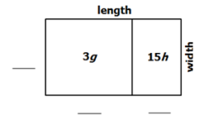  Use the areas given in the rectangle.  What is length of the entire rectangle? | Jessie made 20 ounces of trail mix by mixing granola and peanuts. The ratio of peanuts to granola in the trail mix is 1:4. How many ounces of granola are in the trail mix?
Jessica paid $315.00 for a ring, and the original price was $420.00. How much of a discount did Jessica receive?  A) 20% B) 25%  C) 30% D) 35% | On a recent business trip Mrs. Smith rented a car for a fee of $65 plus $0.15 per mile she drives. What is the most miles Mrs. Smith can drive without spending more than $200?
Homework: Wednesday, February 22, 2017
TRY YOUR BEST! SHOW ALL OF YOUR WORK! NO WORK! NO CREDIT!
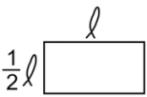  Which expression can be used to represent the perimeter of the rectangle?  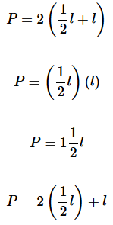  A.  B.  C.  D. | 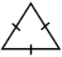  The perimeter of the triangle is represented by 6y + 12. What is the length of each side?
Justin uses$\frac{2}{3}$ of a gallon of paint to cover $\frac{1}{12}$ of his bedroom wall. How much paint is needed to cover the entire wall? | 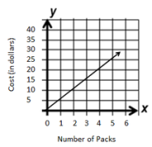  The graph below represents the cost of soda packs as a unit rate of $5 for every pack of soda. The unit rate is represented as $5/pack. If p represents the packs of soda and d represents the cost in dollars, which equation can be used to find the cost of any given number of soda packs?  A) d = 5 + p B) d = 5p  C) p = 5d D) d = 5 ÷ s
The Sanders' cruise vacation cost them $2400 last year. This year, they decide to take another cruise vacation which will cost them $2550.  To the nearest percent, what is the percent of increase?  A) 6% B) 7%  C) 8% D) 9% | Use the information to answer the question. 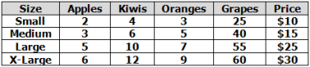Francesca's Fruit Basket Company makes gift baskets containing fresh fruit. The table shows the numbers of each fruit included in different sized baskets and the prices of each basket.  A) apples and oranges B) kiwis and grapes  C) apples and kiwis D) oranges and grapes
Homework: Thursday, February 23, 2017
TRY YOUR BEST! SHOW ALL OF YOUR WORK! NO WORK! NO CREDIT!
Robert found jeans on sale for 20% off. The jeans were originally $65.  How much did Robert pay for the jeans? | Caroline wants to simplify the expression 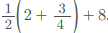. Which description(s) represent(s) correct way(s) to simplify the expression? Select ALL that apply.  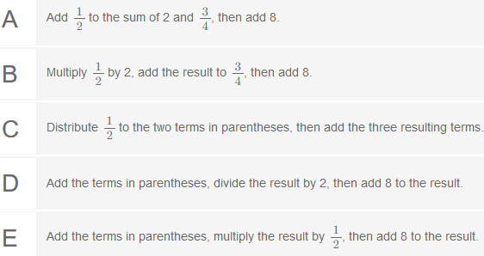
If a person runs $\frac{1}{3}$ mile in $\frac{1}{9}$ of an hour, what is the unit rate per hour?  - $\frac{1}{9}$mi/hr B)$\frac{1}{3}$ mi/hr  C) 3 mi/hr D)9 mi/hr | 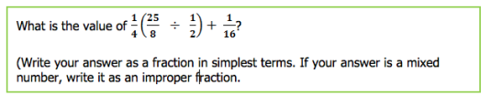
Study for CFA #3 Good Luck Tomorrow!!! You can do it!!! 80% or better!!!!

