Week 17 Name: __________________________
No Homework: Monday, January 2, 2017 (No School) Tuesday, January 3, 2017 (No School)
Homework: Wednesday, January 4, 2017
TRY YOUR BEST! SHOW ALL OF YOUR WORK! NO WORK! NO CREDIT!
About 543 out of every 1,000 people in the United States owned a cell phone in 2003. In Japan, the rate was 68 for every 100 people. How much greater was the percent of cell phone ownership in Japan than in the U.S.? | Which school has the greatest percent of students who own computers? 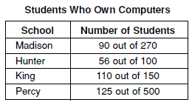
A truck driver can drive no more than 8 hours in one day. He has already driven 3.5 hours. He drives at an average rate of 55 miles per hour. Which inequality could be used to find the distance, d, the truck driver can travel in the remaining time?  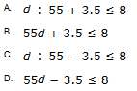 | 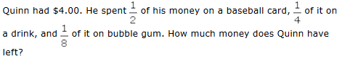  A. $0.25  B. $0.50  C. $1.00  D. $1.25

Homework: Thursday, January 5, 2017
TRY YOUR BEST! SHOW ALL OF YOUR WORK! NO WORK! NO CREDIT!
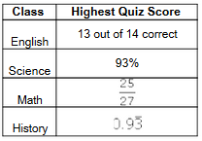  The chart shows the highest quiz score Cynthia received in four of her classes.  In which class did she have the highest score?  A. English B. Science  C. Math D. History | The width of a rectangle is 7 less than its length. Which expression represents the perimeter of the rectangle with a length of x?  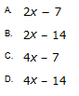
Which expression is equivalent to 3(m + 2) − 4(2m − 9)?  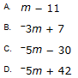 | Four brothers each received $20.00 for helping neighbors with yard work. The chart below shows how much of their money each brother spent.  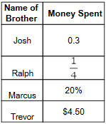  Which brother spent the most money?  A. Josh  B. Ralph  C. Marcus  D. Trevor

