Week 16 Name: __________________________
Homework: Monday, December 12, 2016
TRY YOUR BEST! SHOW ALL OF YOUR WORK! NO WORK! NO CREDIT!
In 2003, 68% of the T.V. set owners in the United States had cable television. Write this percent as a fraction in simplest form and as a decimal. | In a survey, 25 students were asked whether they prefer orange juice or grapefruit juice. Seventeen students said they prefer orange juice. What percent of the students surveyed said they prefer orange juice?
Which expression is equivalent to 3(m + 2) − 4(2m − 9)?
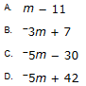

Complete.
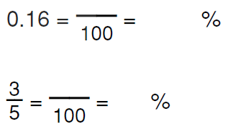

Homework: Tuesday, December 13, 2016
TRY YOUR BEST! SHOW ALL OF YOUR WORK! NO WORK! NO CREDIT!
Four brothers each received $20.00 for helping neighbors with yard work. The chart below shows how much of their money each brother spent.  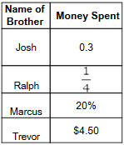  Which brother spent the most money?  A. Josh  B. Ralph  C. Marcus  D. Trevor | A family goes to a restaurant for dinner. The bill for their meal is $75 before sales tax. Sales tax is 7%.They leave a 15% tip. Which expression will calculate the total bill for the family’s meal?  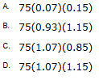

Homework: Wednesday, December 14, 2016
TRY YOUR BEST! SHOW ALL OF YOUR WORK! NO WORK! NO CREDIT!
About 543 out of every 1,000 people in the United States owned a cell phone in 2003. In Japan, the rate was 68 for every 100 people. How much greater was the percent of cell phone ownership in Japan than in the U.S.? | Which school has the greatest percent of students who own computers? 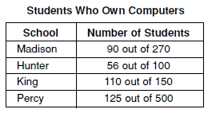
A truck driver can drive no more than 8 hours in one day. He has already driven 3.5 hours. He drives at an average rate of 55 miles per hour. Which inequality could be used to find the distance, d, the truck driver can travel in the remaining time?  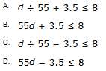 | 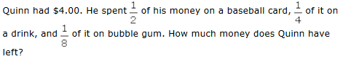  A. $0.25  B. $0.50  C. $1.00  D. $1.25

Homework: Thursday, December 15, 2016
TRY YOUR BEST! SHOW ALL OF YOUR WORK! NO WORK! NO CREDIT!
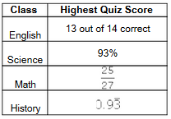  The chart shows the highest quiz score Cynthia received in four of her classes.  In which class did she have the highest score?  A. English B. Science  C. Math D. History | The width of a rectangle is 7 less than its length. Which expression represents the perimeter of the rectangle with a length of x?  