Week 21 Name: __________________________
Homework: Monday, January 30, 2017
TRY YOUR BEST! SHOW ALL OF YOUR WORK! NO WORK! NO CREDIT!
Toilet paper is sold in cases of 36 rolls for $14.99. What is the price per roll? | Write and solve the proportion to describe the following: 47 is 62% of what number?
The sum of two consecutive even numbers is $54$. Find the numbers. | The combined ages of Abby, Brian, and Calvin is 33. Abby is twice Brian's age and three times Calvin's age. How old is Abby? Write an equation which solves for Abby's age, a.
Homework: Tuesday, January 31, 2017
TRY YOUR BEST! SHOW ALL OF YOUR WORK! NO WORK! NO CREDIT!
In a class of 25 students, 12 are boys and 13 are girls. What is the ratio of boys to girls? | Some middle-school students were asked how they got to school each day. The results are shown in the circle graph. Sixty students said they rode the school bus. How many total students does the circle graph represent?  A) Write an equation that could be used to find the total number of students represented by the graph.  B) How many students does the circle graph represent?
Lucas can run 2 miles in 25 minutes. How long would it take him to run 1 mile?

Kevin is currently twice as old now as his brother. If Kevin was $8$ years old $2$ years ago, how old is Kevin’s brother now?

Homework: Wednesday, February 1, 2017
TRY YOUR BEST! SHOW ALL OF YOUR WORK! NO WORK! NO CREDIT!
Elijah can read 75 words per minute. What is his speed in words per second? | Jessie invests $3,345 in the stock market. Over the 3 years he has this invested, he gets a return of 7.8%. How much will his investment be worth after 3 years?
Three students conduct the same survey about the amount of coffee people drink in the morning. The results of the number of people who drink coffee are shown below. In which survey did people drink the most coffee?  - Debbie reported that 21 out of 50 people she surveyed drink coffee in the morning.  - Allen reported that 45% of the people he surveyed drink coffee in the morning.  - Benny reported that 0.495 of the people he surveyed drink coffee in the morning. | Find the constant proportionality in the following:  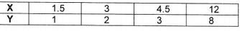  a.  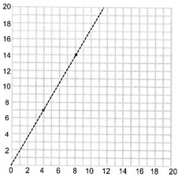  b.
Homework: Thursday, February 2, 2017
TRY YOUR BEST! SHOW ALL OF YOUR WORK! NO WORK! NO CREDIT!
Karla is going to the store. She bought a banana for $0.67, a jar of peanut butter for $2.35 and a bottle of water for $1.50. If she paid with a $5 dollar bill, how much change will she get back? | At what rate would you need to invest $12,000 to make $1824 after 4 years?
Find the constant proportionality in the following:  a.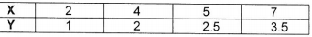  b. 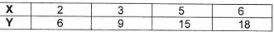 | Write and solve the proportion to describe the following: 28 is 4% of what number

