Grade 7 Week 26 Name: ____________________________________
Homework: Monday, March 6, 2017
TRY YOUR BEST! NO WORK NO CREDIT!
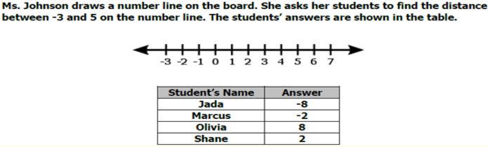
Which student finds the correct value?

Using the number line, what is the value of –(-6) – 4?

To make lemonade, you can mix 4 teaspoons of lemonade powder with 16 ounces of water. What is the ratio of powder to water?  If there are 128 ounces in 1 gallon, how much of each would you need to make a gallon? | The diameter of a clock is 7 inches. What is the circumference of the clock? Use 3.14 for $π$ and round to the nearest whole number.
Area of a circle can be determined using the formula:  $$A=πr^{2}$$  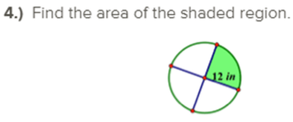 | The low point of the Tonga Trench, in the Pacific Ocean, is -10,630 meters. The low point of the Mariana Trench, also in the Pacific Ocean, is 890 meters lower. What is the depth of the Mariana Trench?
Complete the table for the given ratio: 9 triangles per 6 circles  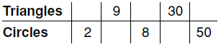 | A jewelry store is having a going-out-of business sale. All merchandise is marked 40% off the regular price. The regular price of a watch is $59.95. Find the amount of the discount and the sale price.

Homework: Tuesday, March 7, 2017
TRY YOUR BEST! NO WORK NO CREDIT!
There are 45 students on the school football team. This is 13 more than the number of students on the basketball team. How many students are on the basketball team? | Enrollment in the Jacksonville Township Basketball League was 425 last year. This year, the number enrolled increased 12%. If enrollment drops 12% next year, how many people will be enrolled in the league? Round to the nearest whole number.
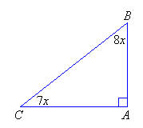  The triangle below is a right triangle. Find ∠B. Show your work. | The total bill for a bike rental for 8 hours was $38. How much per hour was the rental cost?
 | New Orleans, Louisiana, is 6 feet below sea level. The highest point in Louisiana, Driskill Mountain, is 541 feet higher than New Orleans. How high is Driskill Mountain?
Jim’s Gym had income of $20,350 last month. The total increased by $2,000 this month. What was the percent increase to the nearest percent?

A 11% B 7%
C 10% D 6%

Homework: Wednesday, March 8, 2017
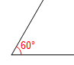
TRY YOUR BEST! NO WORK NO CREDIT!!
C
A jar lid has a diameter of 42 millimeters. What is the circumference of the lid? Use 3.14 for $π$. | In 1975, the minimum wage was $2.10 per hour. Write and simplify an expression to show wages earned in a 35-hour week after a $12 tax deduction.
Find the perimeter of the figure below. 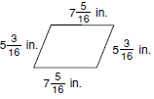 | 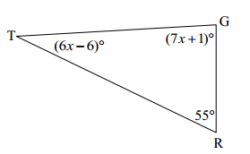  What is the correct measure of ∠T in the triangle pictured below? Show your work.
The school band is raising money for a trip. The members ordered 5 dozen jerseys for $7 each and sold them for $12 each. They also ordered 4 dozen sweatshirts for $11 each and sold them for $18 each. The band paid $35 to create the design.  Write and simplify an expression to calculate the band’s variable costs for the clothing. | 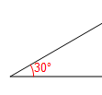  Which pair of angles form complementary angles?  B  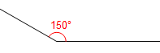  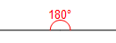  A  F)  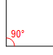  D  E
What are the relevant angle relationships in the diagram? Write an equation for the angle relationship(s) shown in the figue and solve for x.

Homework: Thursday, March 9, 2017
TRY YOUR BEST! NO WORK NO CREDIT!!
Until June 2002, the simple interest rate on Stafford loans to college students was 5.39% while the student was still in college. How much interest would a student pay on a $1,500 loan for 2 years?  I = Prt | The measures of two supplementary angles are in the ratio of 2:3. Find the two angles.
Milton collects sports trading cards. He has 80 baseball cards. He has half as many basketball cards as football cards. He has 20 more hockey cards than basketball cards and half as many football cards as baseball cards. How many hockey cards does he have? | Find the composite area.  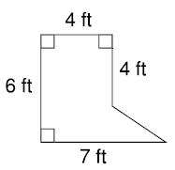
The expression 24g gives the number of miles Guy’s car can travel on g gallons of gas. If the car has  6 gallons of gas left, how much farther can he drive? | Mel is 3 years older than Rahfat and Aurelio is twice as old as Mel. The sum of their ages is 57. How old is Mel?
Find the side length of the triangle given the perimeter ($P)$. Then classify the triangle by its side measures. $P=84.3$ in. | In a pair of complementary angles, the measurement of the larger angle is three times that of the smaller angle. Find the measurements of the two angles.

